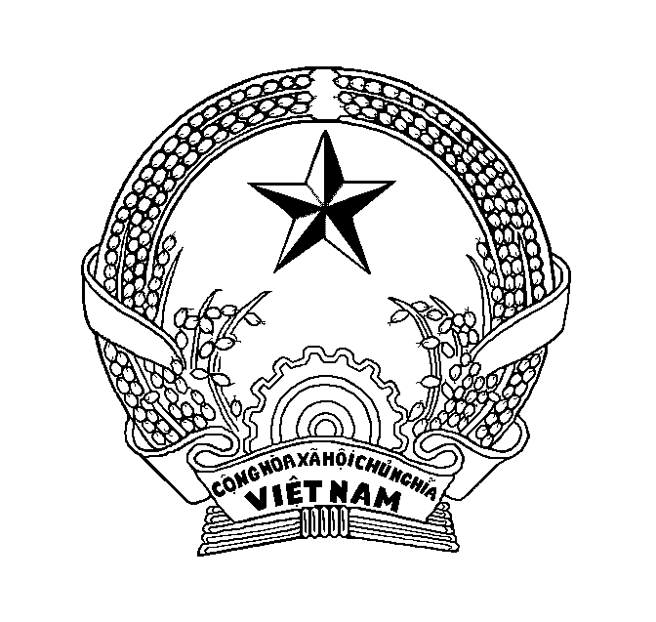  PEOPLE’S COMMITTEE  OF LANG SON PROVINCE  No : ….. /CH-NV | (Mẫu 1.2: Công hàm soạn bằng tiếng Anh)
The People’s Committee of Lang Son Province presents its compliments to the Embassy of (tên nước) ………and has the honour to………
……………………………………………………………………………… ……………………………………………..………………………………………………………………………………………………………………………………………………………………………………………………………………………………………………………………………………………………………………………………………………………………

……………………………………………………………………………………………………………………………………………………………………………………………………………………………………………………………………………………………………………………………………………………………………………………………………………………………………………………………………

The People’s Committee of Lang Son Province avails itself of (takes) this opportunity to renew to the Embassy of (tên nước)…. in Ha Noi the assurances of its (their) highest consideration.
Chữ ký nháy
Lang Son, … April 2016

Dấu UBND
tỉnh Lạng Sơn

Embassy of (tên nước)
HA NOI

